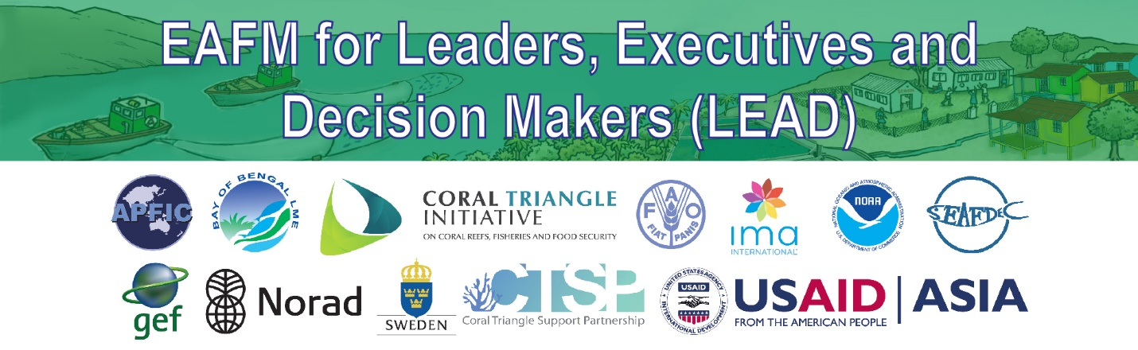
EAFM One-hour High-level Consultation for Leaders, Executives and Decision Makers (LEAD): Session Plans
Note: This session plan sets out an example agenda. Facilitators can adapt the agenda using any of the tools in the LEAD tool kit and then update the outline and the agenda accordingly. The toolkit is flexible and adaptable and can be used as the facilitator sees fit.

For this agenda, LEADers need to agree on a topic of interest/concern (“hot topic”) prior to the consultation. The “hot topic” is agreed upon through consultation prior to the HLC and is based on the LEADer’s perception of what is a “hot topic” for them. The HLC facilitators can suggest one or several “hot topic(s)” and get feedback from their own LEADers on suitability.

Timing is indicative only and needs to be adjusted according to the audience. For example if LEADers do not know each other, more time will be required for introductions etc

Important to have everything set up and well thought through BEFORE the Consultation, as every minute will count.

Topic/session | Activity Guidance | What facilitator needs to know | Resources | Time
I. Opening and Introductions | Objective: To introduce participants and facilitators, set the stage on what will be covered and how the consultation will be conducted.  1. MC introduces the consultation  Explains the context (i.e. The “hot topic”) that has been decided earlier. Use statistics or facts to help summarize urgency and severity of impacts  Speaks to a handout including:  - Objective of the consultation  - Annotated agenda  In this example the hot topic is “IUU fishing” | 1. Refer to “key elements of being a good facilitator”  2. Why the “hot topic” to be discussed during the HLC was selected and why its important for LEADers  NOTE:  Try to start on time, but keep in mind that adjustment is needed if meeting starts late.  Prepare alternatives to make up for lost time. | List of participants  Handout with  - Objective  - Agenda | 10 mins
II. Overview of EAFM: What and why EAFM | Objective: leaders understand why EAFM is needed for sustainable fisheries and what it is.  1. Presentation on the Ecosystem Approach to Fisheries Management  - Start the video (11-min full version)  - OR presentation based on the brochure - take LEADers through the brochure page by page but do not read the details  2. Brief discussion on EAFM activities that are already going on in their country. | 1.Thorough understanding of the why and what of EAFM (to be able to explain convincingly to leaders)  - If using the brochure, *summarize* and elaborate on only 2 or 3 of the 7 principles (e.g. “Precautionary Approach” and “Scale”) | Reference E-EAFM: Handbook Modules 2 & 3  The why of EAFM [Toolkit- Conversations]  What is EAFM [Toolkit- Conversations]  FAQs [Toolkit- Conversations]  11-min Video OR Brochure | 20 mins
III. How EAFM can help | Objective: To examine how EAFM can help with the “hot topic”  1. Describe how EAFM can help address the hot topic in terms of the different components and their interactions in an ecosystem.  2. In this example we use a “Problem tree” of IUU that shows how different components interact and the causes of the problem.  Introduce the “Problem tree”  Questions  Does this reflect the situation in your country? If not, why not?  What sorts of management measures could be used to address the causes?  Output: A revised problem tree | Facilitator needs to be familiar with the hot topic and advantages in using EAFM to address it. Think about trade-offs in advance.  See FAQ on “How would EAFM help us combat IUU?” [Conversation A5]  1. Stress that EAFM  - Looks holistically at the bigger picture and address causes of the problem  - Looks for linkages and interactions  - Prioritizes issues so that high priority is given to those that are high risk and can be addressed through management actions  2. Facilitator will need to prepare a handout of a problem tree before the HLC.  Have a thorough understanding of the Problem Tree concept. | Reference E-EAFM: Handbook Modules 6, 7  FAQs [Toolkit Conversations]  Problem tree on IUU (Annex) | 15 min
IV. Follow-up actions | 1. Inform participants about EAFM  capacity development materials and resources  - Refer to brochure with capacity development inserts on E-EAFM and LEAD toolkit  - Emphasize eafmlearn.org as a website where materials can be found  2. Plenary discussion on key next steps | Facilitators need to be well familiar with the EEAFM and LEAD materials and the on-line resources  Refer to brochure and flyers,  Do not describe every tool. Summarize by saying that they cover different audiences and range in materials from a 1 minute to 1-day engagement with leaders to a 1 week training comprehensive package for managers and resource persons. | Brochure and the 2 flyers  Screen shot of the Web page | 10 mins
VI. Closing | 1. Summary by facilitator  2. Closing statements | Facilitator very briefly summarises the consultation pointing out that each individual leader has a role to play  Facilitator selects and mentions relevant points on the “Why EAFM” material to conclude. | “What is in it for you and your agency” from the PPT and also “Why EAFM [A3: Conversations] | 5 mins
Annex 1: List of issues relating to the hot topic. In this example - IUU fishing

Poverty among fishing communities/declining economic opportunities among fishers/fishing becoming unsustainable source of livelihood
Climate change
Habitat degradation
Destructive fishing practices
Overcapacity and overfishing
Weak Monitoring Control and Surveillance (MCS)
Lack of cooperation and coordination among Agencies
Financial incentives
Weak legislation, especially sanctions
Lack of awareness of rules & regulations by stakeholders
Lack of dialog with neighbouring countries
Open access fishery
Lack of effective registration and licensing
High proportion of small low value/trash fish
Pollution
Migrant labour

